Applicant Info
Role
First Name
Last Name
Phone
Email

Business Info
Name
Address
City
State
Phone
Email

Opt in to receiving text messages and other communications (Yes / No):
Example of one page of ads.
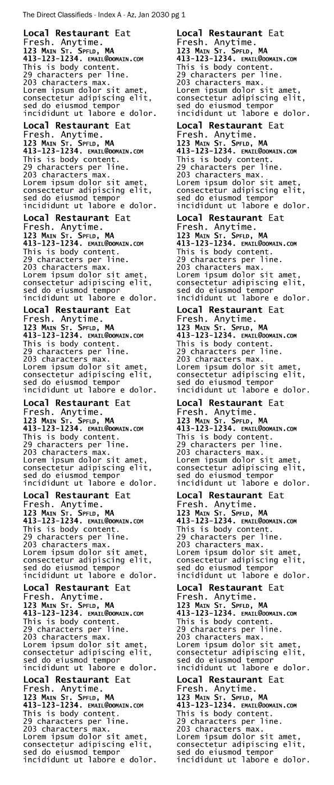
Not to scale. Image has been shrunken to fit to page.
Please zoom in to view.
Each ad slot is 1”h x 1.5”w.
The first example ad slot is circled in blue.
Its title is “Local Restaurant”.
Its subtitle is “Eat Fresh. Anytime.”.
The business location and contact details are listed before the body content that starts with “This is body content”.
It shares the page with other ads.
There are a limited amount of ad pages before the arts and entertainment section begins.

The following content is not allowed:
Illegal Content
Hateful or Discriminatory Content
Violent or Dangerous Content
Sexually Explicit or Pornographic Content
Deceptive, Fraudulent, or Misleading Content
Malicious Content
Spam or Low-Quality Content
Invasion of Privacy
Unlicensed or Unlawful Commercial Use
Intellectual Property Violations

Ad Proposal
Title
Subtitle
Body Content

I certify that all information provided in this form is true.

Signature
Signature
Date

Content Release Authorization
I, the undersigned, hereby grant The Direct Classifieds (the Released Party) and its parent/subsidiary companies the irrevocable right and permission to use the content (herein the Ad Proposal Form and any information/content related to the Advertisement provided to the Released Party) created by or featuring me.
This content may be used in whole or in part, for any lawful purpose, including but not limited to:
- Promotional content for The Direct Classifieds and parent/subsidiary companies.
- Educational purposes
- Print and digital publications for The Direct Classifieds and parent/subsidiary companies.
- Rendering services for the undersigned including but not limited to advertising.
I understand that:
- I will not receive any compensation for the use of this content.
- I waive the right to inspect or approve any use of the content (with the exception of any pre-publish inspection offered to the undersigned).
I release and discharge The Direct Classifieds, its legal representatives, employees, agents, and assigns from any and all claims and demands arising out of or in connection with the use of the content, including but not limited to any claims for defamation, invasion of privacy, or violation of rights of publicity.
This authorization is perpetual, worldwide, and irrevocable.

Signature
Signature
Date

Service Agreement
The Undersigned (the Applicant, the representative of the Business) proposes the publishing of the advertisement contained herein for the Business represented by the Undersigned.
The advertisement shall be contained within a 1” long by 1.5” wide ad slot on a common ad page shared by other advertisers and published by the Released Party.
Before payment pending, there is no obligation of the Undersigned to commit.
After approval by the Released Party, the Undersigned commits to the publishing of the Advertisement by fulfilling the financial obligations for the service received: $100 paid by the Undersigned to the Released Party in full, per each ad being published, per each month the ad is published.
After the above mentioned payment transaction has cleared, The Released Party agrees to render the service of publishing the Advertisement and distributing it to a number of addresses within a geographical region the Business is located and determined by the rate of 4 cents per address (i.e in this agreement: 2500 addresses).
The agreement renews automatically on a monthly basis. The Undersigned reserves the right to cancel their recurring subscription at any time, exiting the agreement. The Released Party reserves the right to deny service at any time, exiting the agreement.

Signature
Signature
Date

Privacy Statement
We collect information to render services, manage your account, improve our products and services, and offer other products and services. This may include personal information about you, your usage of our services, and/or your company.
We may use personal information to personalize your experiences with our company and services.
We may pass on personal information to our group of companies so that they may offer you their products and services.
We do not share your information for marketing purposes with companies outside of our group without your consent.
We may share your information with legal authorities when requested and required by law.

Signature
Signature
Date

Liability Waiver
Limitation of Liability
To the fullest extent permitted by applicable law, in no event shall The Direct Classifieds, its affiliates, directors, officers, employees, agents, licensors, or service providers be liable for any indirect, incidental, consequential, special, exemplary, or punitive damages, including but not limited to lost profits, lost revenue, loss of data, or other damages arising out of or in connection with your use of, or inability to use, our services or content, whether based in contract, tort (including negligence), strict liability, or otherwise, even if we have been advised of the possibility of such damages.
In no event shall our total liability to you for all claims relating to the services exceed the greater of (1) the amount you paid to us for the services in the last month preceding the claim or (2) $100.

Disclaimer of Warranties
Our services are provided on an “as is” and “as available” basis. We make no warranties or representations, express or implied, about the operation or availability of the services, or the information, content, or materials included in them.
To the fullest extent permitted by law, we disclaim all warranties, express or implied, including but not limited to implied warranties of merchantability, fitness for a particular purpose, non-infringement, and accuracy.

Indemnification
You agree to defend, indemnify, and hold harmless The Direct Classifieds and its affiliates from and against any and all claims, damages, obligations, losses, liabilities, costs, or debt, and expenses (including attorney’s fees) arising from:
- your use of and access to the service;
- your violation of any term of these Terms;
- your violation of any third-party right, including any copyright, property, or privacy right.
I hereby confirm that I, the Undersigned, and the Business aforementioned that I represent, agree to all terms in this form.

Signature
Signature
Date

